## 1.DATA ANALYTICS [ ASSIGNEMENT 3]

Sets: A dataset is acollection of related data items that canbe accessed individuallyor in combination.Datasets are a fundamental tool indata analytics, providing the data upon which analysts draw in sight sand trends .There are two types of sets: dynamic sets and fixed sets.The members of a dynamic set change when the underlying data changes .Dynamic set scan only be based on a single dimension.

* 1. Top 10 states with most profit.
  2. Products with less discount.

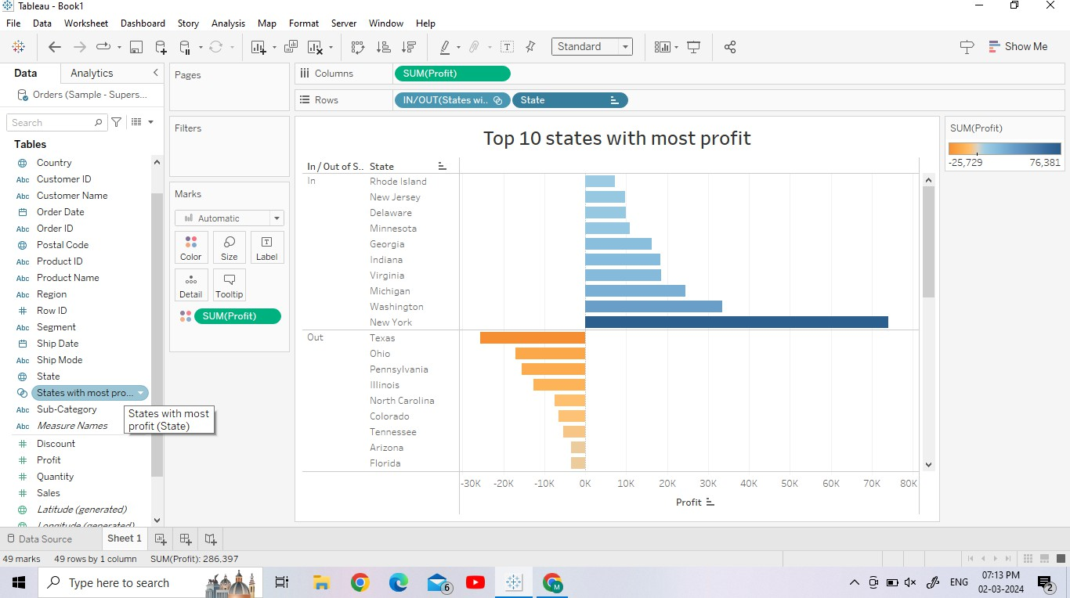

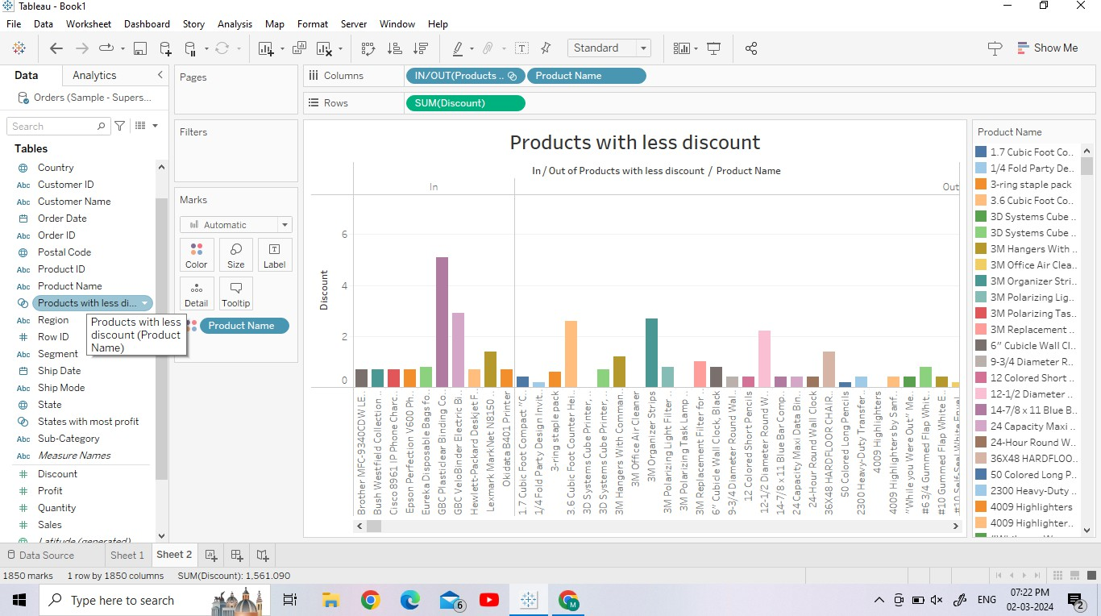

1. Combining sets: InTableau,a combined set is a custom field that holds a subset of data based on a given condition. Combined sets can be created in a Tableau worksheet to perform further operations.

**Combined Set in Tableau:**

* 1. Select these that want to be combined.
  2. Right-click on the selected part.
  3. Click on create combined set.
  4. Add/modify the values(optional).
  5. Your combined set is ready.

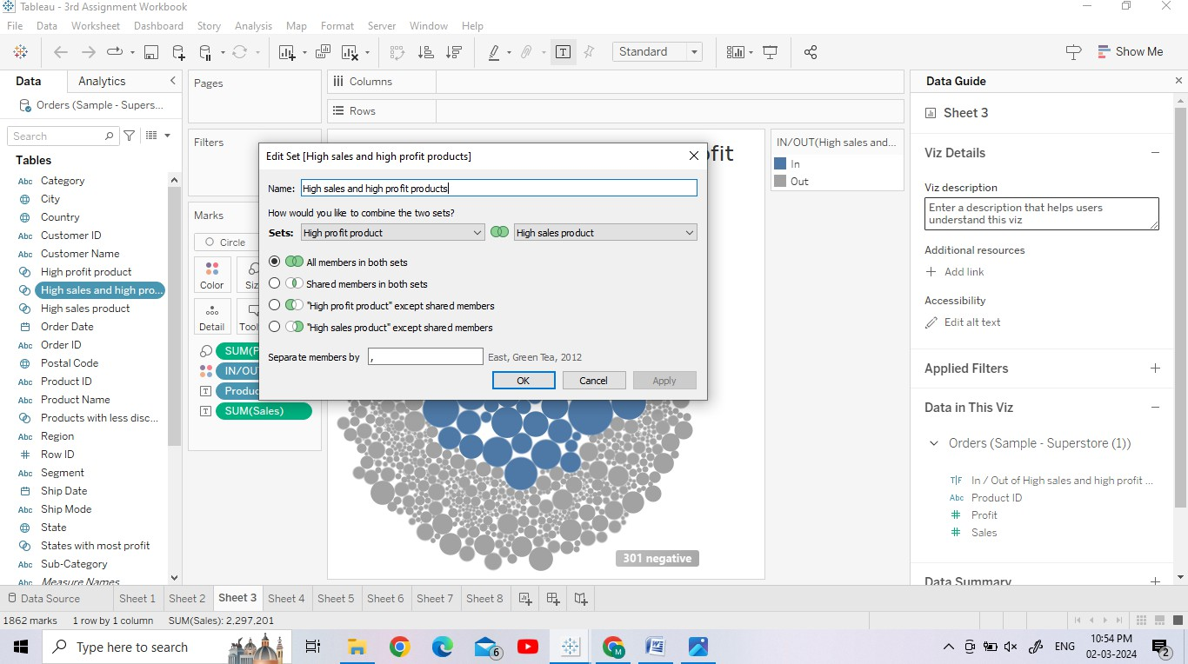

**Union:**Unionis a method for combining data by appending rows of one table onto another table. For example, you might want to add new transactions in one table to a list of past transactions in another table.

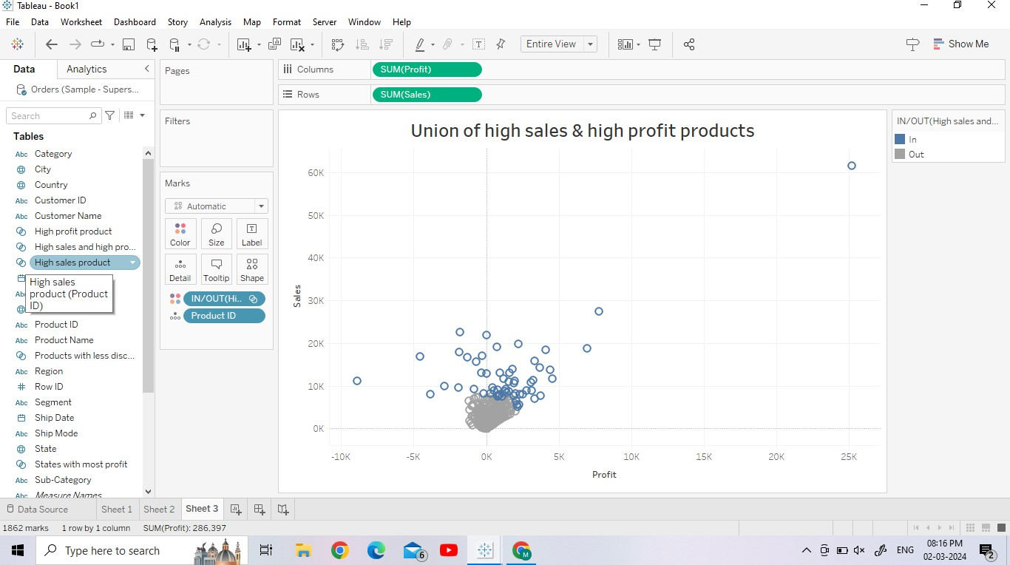

**Intersection:** the Intersects calculation inTableau,which allows you to find spatial intersections via calculated fields at the workbook level—rather than in a join

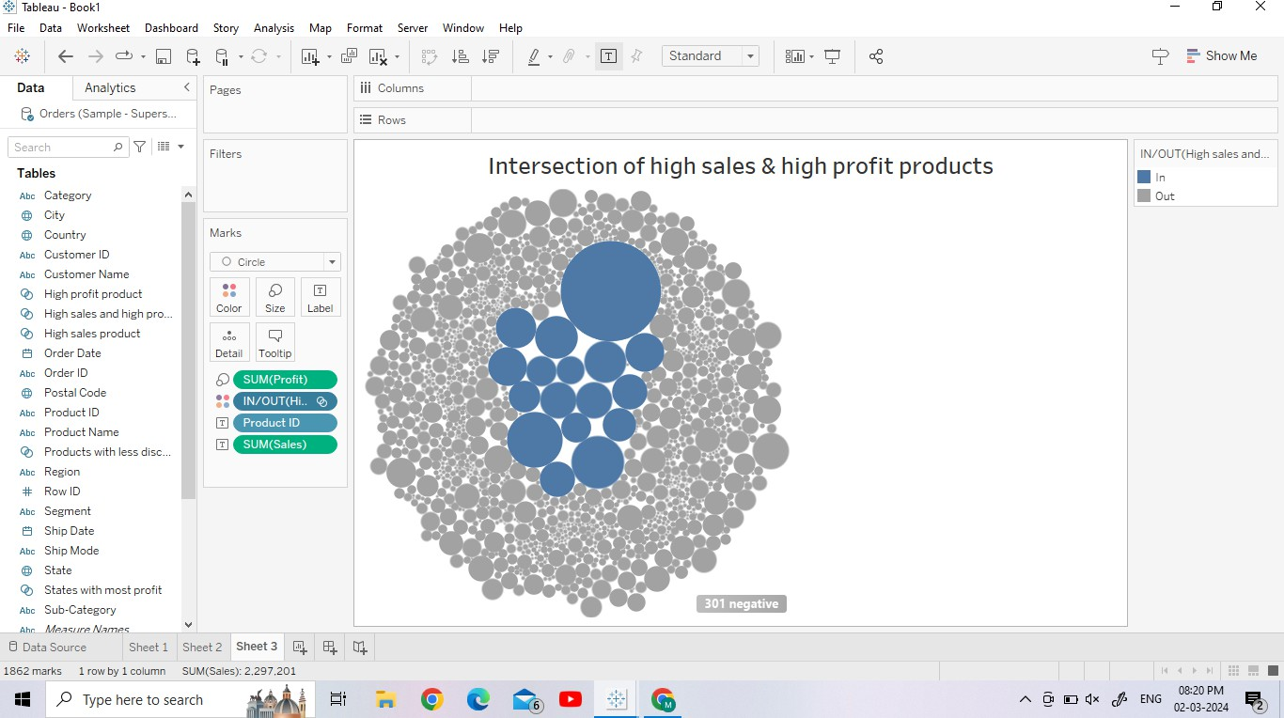

Minus: In Tableau,"minus" typically refers to a subtraction operation performed on numerical values. Tableau provides various mathematical operators that you can use within calculated fields to perform arithmetic operations, including subtraction.

1. Calculated fields : Calculated fields inTableau allow you to create new fields(orvariables) based on a formula that you define. These field scan be created using existing fields in your data source, constants, or functions provided by Tableau. Calculated fields are useful for performing complex calculations, custom aggregations, or creating new dimensions or measures that are not present in the original dataset.

Aggregate function: Aggregate functions in Tableau are used to perform calculations on groups of data rather than individual records. These functions take a set of values and return a single value, often summarizing oraggregating the data in someway.Tableau provides a variety of aggregate functions that you can use to analyze your data effectively.

**Ex:** Sum, Avg, Min, Max, Count, Median etc…

* 1. **Sum of Profit**

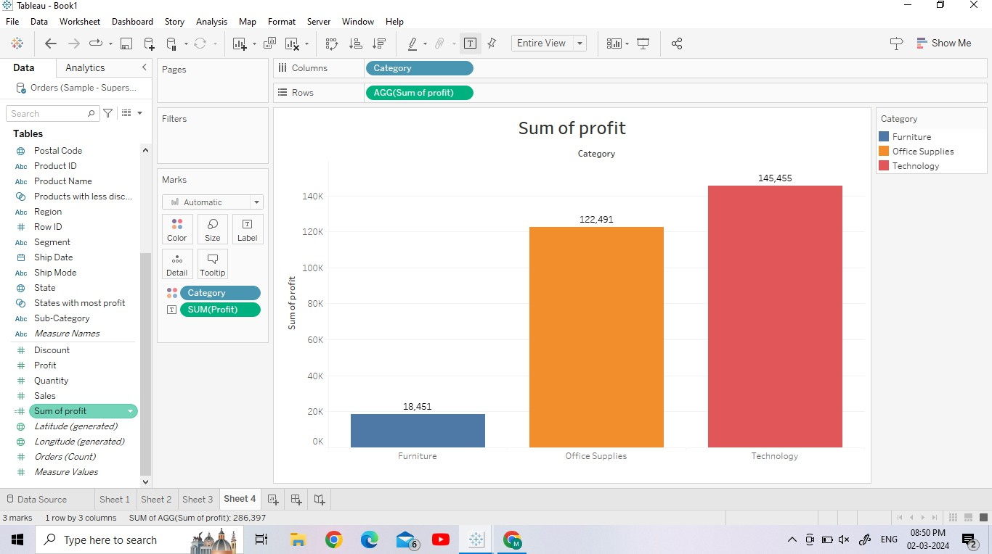

* 1. **Median of Sales**

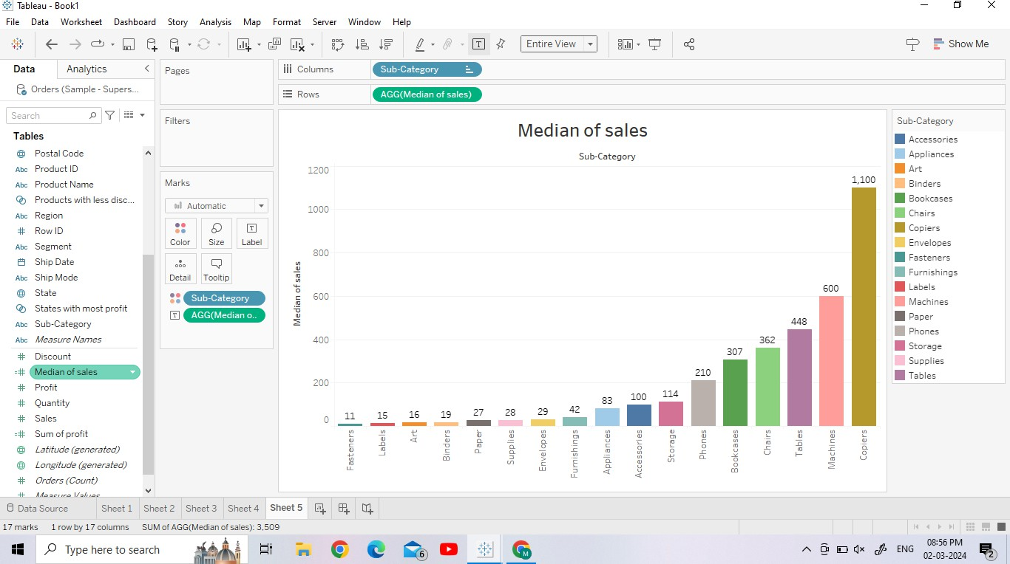

1. Quick Table Calculations: Quick table calculations in Tableau are a set of built- in calculations that allow you to perform common analytical operations quickly and easily on your visualizations.These calculations are applied directly to the data displayed in your visualization, without the need to create complex calculated fields. Quick table calculations are especially useful for performing operations like percent oftotal, running total, moving average, and more.

**Ex:**Percentoftotal ,RunningTotal ,Rank ,Moving Averages ,Percentile, Differenceetc..

* 1. **Running Total:** A running total, also known as a cumulative total, is a type of calculation that shows the total of a measure as it accumulates over a specified dimensionororder.InTableau,you can create a running total using a quick table calculation or by creating a calculated field.

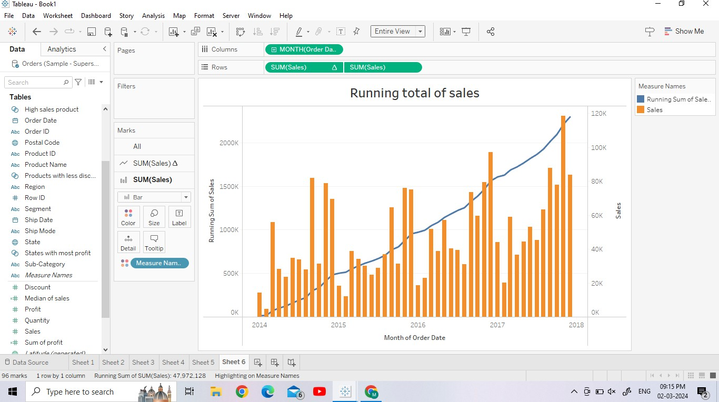

**Percent Difference:**To calculate the percent difference in Tableau,you can use a calculated field. The percent difference typically compare the difference between two values and expresses it as a percentage of one of those values.

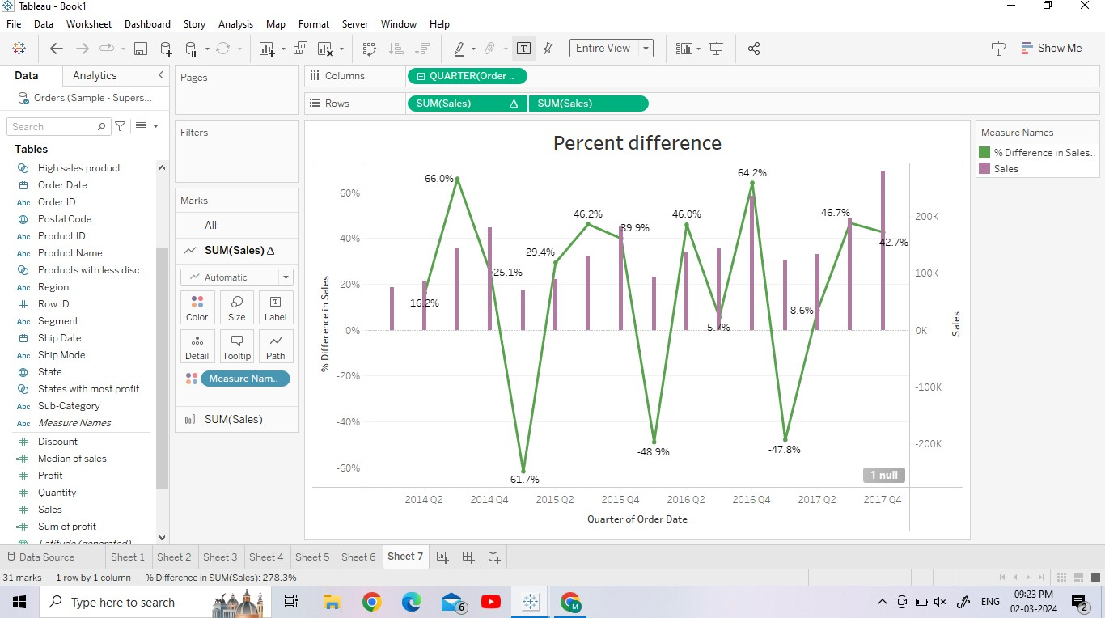

* 1. **YTD Growth:** To calculate Year-to-Date (YTD) growth in Tableau, you can use a calculated field.YTD growth compares the value of a measure for the current period to the same period in the previous year, expressing the difference as a percentage.

